The Pieces (36):
Name | Nbr | Rank | Picture | Moves
Flag/Void | 1 | 0 |  | Stationary
King | 1 | 6 |  | 1 any dir
Queen | 1 | 6 |  | 2 any dir
Wizard | 1 | 6* |  | 3 any dir
Dragon | 1 | 6* |  | 6 any dir**
Captain | 2 | 5 |  | 4 any dir***
Lieutenant | 4 | 4 |  | 3 any dir
Knight | 4 | 3 |  | 3 any dir
Assassin | 1 | 2+ |  | 1 any dir
Footman | 20 | 1 |  | 1 any dir
*-The Wizard ranks as high as any other piece but can be killed by any officer by a roll of 5 or 6.
*-The Dragon ranks as high as any piece, but can only be killed by a Knight or above, and only with a roll of 6.
**-The Dragon can ‘fly’ over intervening pieces when moving.
***-Each Captain can perform a ‘Zed Inel’ once per game. This move involves swapping places with the flag, if the flag is within 4 moves.
+- The Assassin can be killed by any piece except a Footman, But if the Assassin is making the move, he automatically kills whatever piece he opposes, with the exception of the Dragon.

Note: This document can be printed as a folding booklet for your convenience.
The Game of Sanae
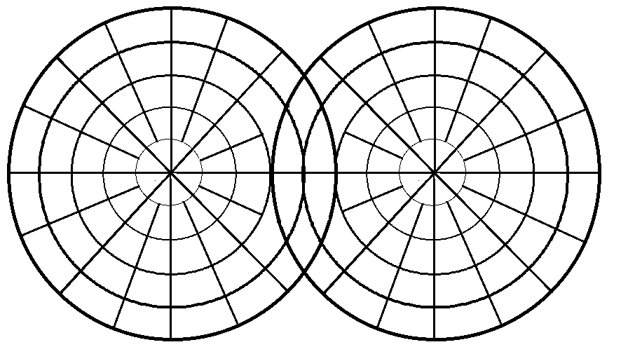
The Game of Sanae, or Spots, is a strategy game played on a board made up of two circles that cross in the middle. The pieces are identical round colored stones, with spots or symbols on the bottom.

Goal:
The goal of the game is to capture the opponent’s Void, or No Spot, representing his Flag.

Materials:
Game Board, 36 red pieces, 36 blue pieces, and 2 6-sided dice. Game board, rules, and pieces can be downloaded from www.Lynvia.com and printed on Card stock.

Board:
The board is composed of two overlapping circles, divided into concentric rings and arcs. In initial setup, pieces can be placed anywhere in one’s own circle, on any arc segment, except in the shared ‘Contended Ground’ between the two circles.

Setup:
Players place their pieces on the board anywhere in their own territory, but not in the Contended Ground.

Gameplay

Players roll to see who goes first. Winner of the beginning roll moves a piece forward. Pieces cannot share a segment with another piece of their own color.
When a piece moves into an opposing color’s square, both pieces must ‘flip’ to expose their rank. Once flipped, a piece must stay flipped. Any piece that moves more than one square at a time must be flipped to reveal it. All higher ranking pieces may of course stay unflipped if the player chooses to move only one square at a time.
The higher rank of the two pieces in the disputed square wins, and captures the other piece.
If two pieces in a disputed square are of the same rank, both players roll the dice, the higher roll wins.
Wizard:
If one of the pieces in a disputed square is the Wizard, the Wizard automatically wins unless the piece is a Lieutenant or above. If so, the other player and the wizard roll a die. If the other player wins the roll, and the die is a 5 or 6, the Wizard loses.
Dragon:
If one of the pieces in a disputed square is the Dragon, the Dragon automatically wins unless the other piece is a Knight or above. If so, the other player and the Dragon roll a die. If the other player wins the roll, and the die is a 6, the Dragon loses.
Flag:
If the flag is in danger of capture by an opposing piece, a Captain can swap places with the flag. This move can only be performed once per game per Captain, and is called Zed Inel, or ‘Showing the Flag’. This switch is performed during an opponent’s challenge to the flag.
Endgame:
If a piece moves into a square occupied by the opponent’s flag, the piece automatically wins and the capturing side is the winner.
However, if a Player has both his King and Queen captured, this only results in a draw.

Strategy

Overview:
The capture of the flag ends the game. Therefore, keeping the location of the flag secret is paramount to preventing a loss. Obviously, most players keep the flag behind a wall of higher ranking officers, but this does not protect the flag from the dragon, who can jump intervening pieces to capture it.
Therefore, killing the opponent’s dragon is usually attempted early on in the game. Some players keep the dragon’s identity secret by moving it only one square at a time until midgame or when the dragon is challenged.
Once the dragon is revealed, it usually wreaks havoc on the opposing team until destroyed by a lucky roll.

Opening:
The usual process in setup is to place the lower ranking pieces forward, officers in the middle, and the highest ranking pieces in the back. Usually the flag is placed somewhere on the back two rows to protect it.
All players normally move a square at a time, using their lowest ranking pieces to reveal the identity of the higher pieces, then capturing them with their own higher-ranking pieces by revealing them in a longer move with a capture.
Midgame:
The Dragon and Wizard usually rule the midgame, once revealed, and help eliminate the higher pieces of the opponent army until they are captured themselves. Some players however begin with the Wizard and Dragon early in the game, using the wizard to destroy the front ranks and the dragon to jump over and look for the flag.
Endgame:
The flag is key to the game, so protecting its identity is crucial. Once the flag’s identity is revealed, if a Captain is within 4 squares, he can perform a Zed Inel, to swap places, and keep the flag from capture. Therefore, eliminating the Captains in midgame is desired.
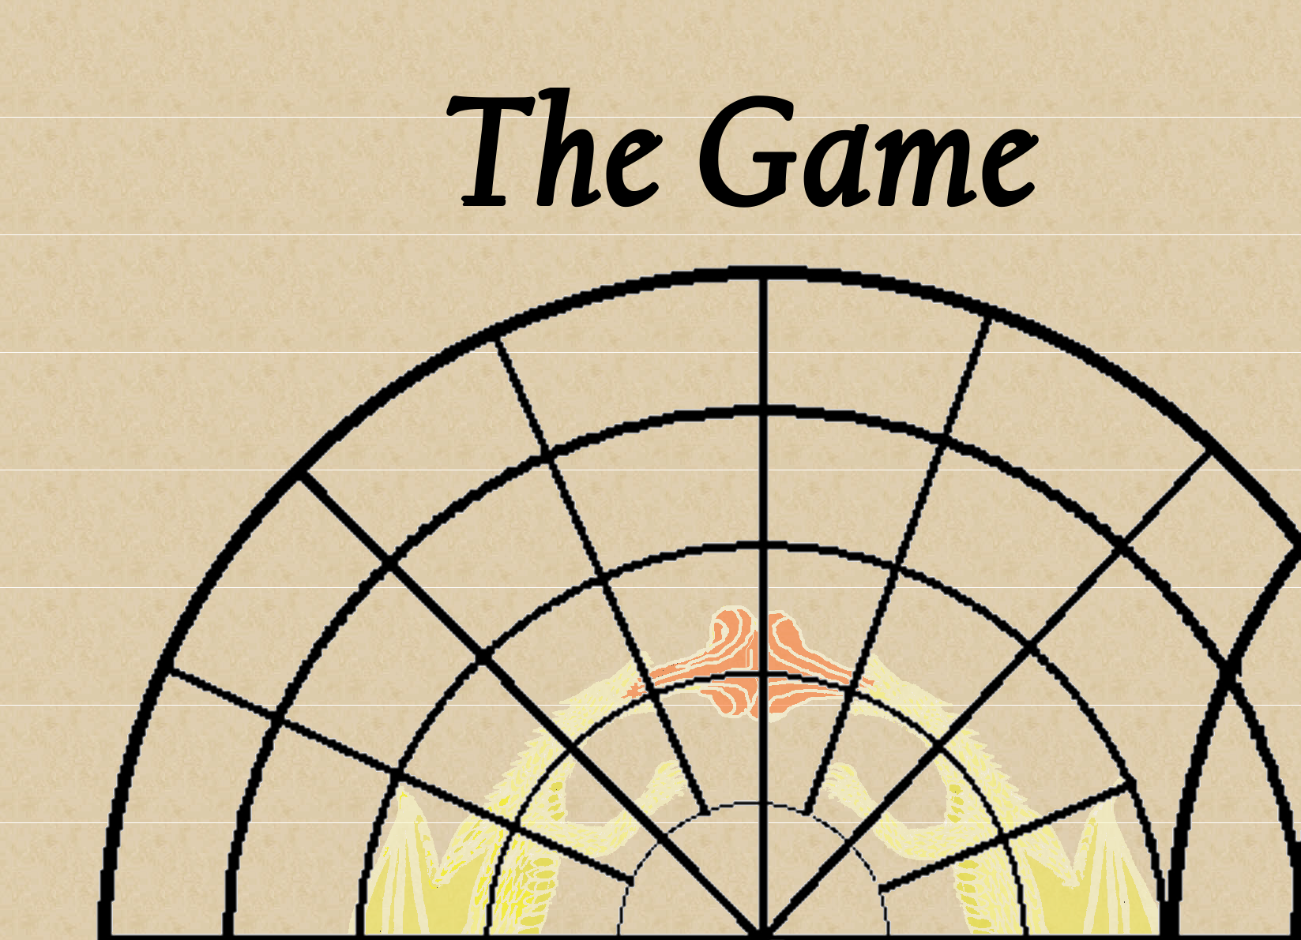

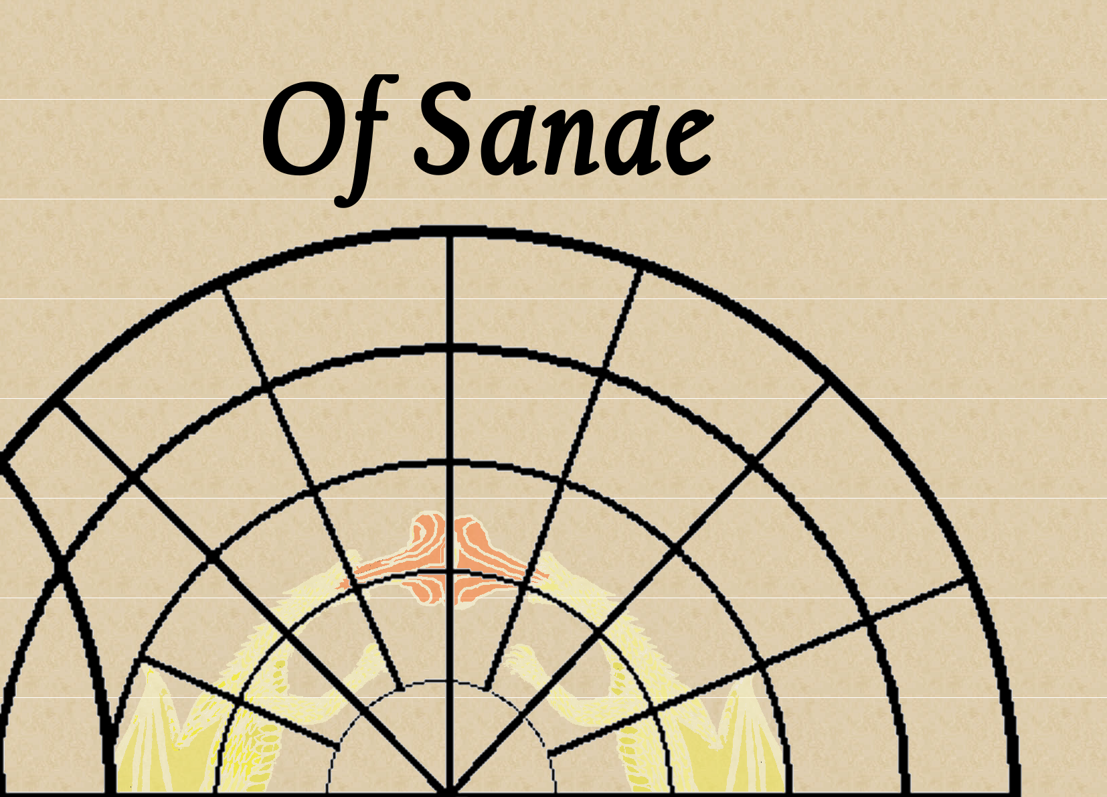

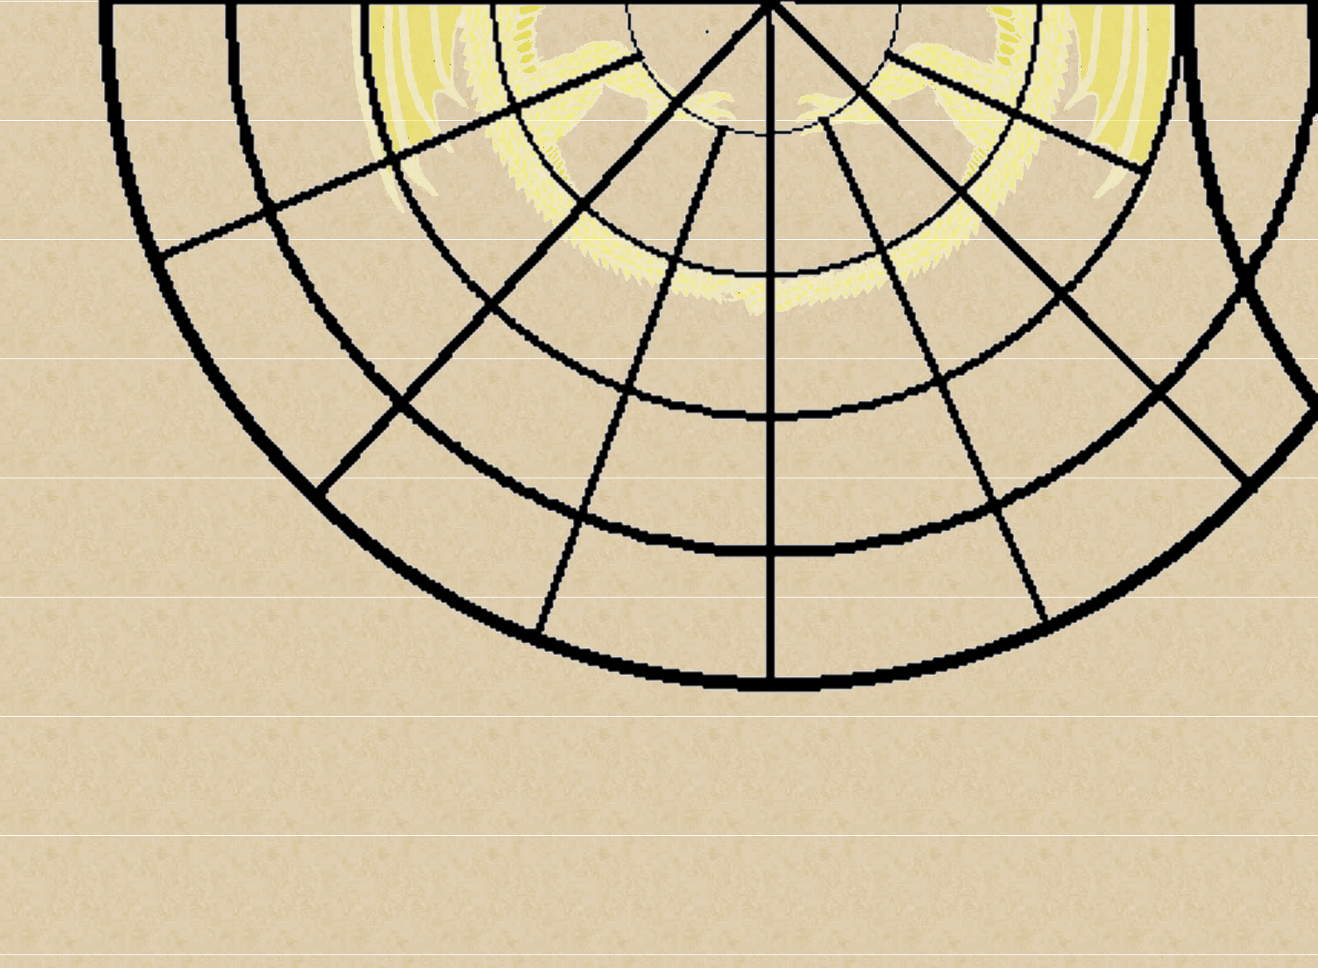

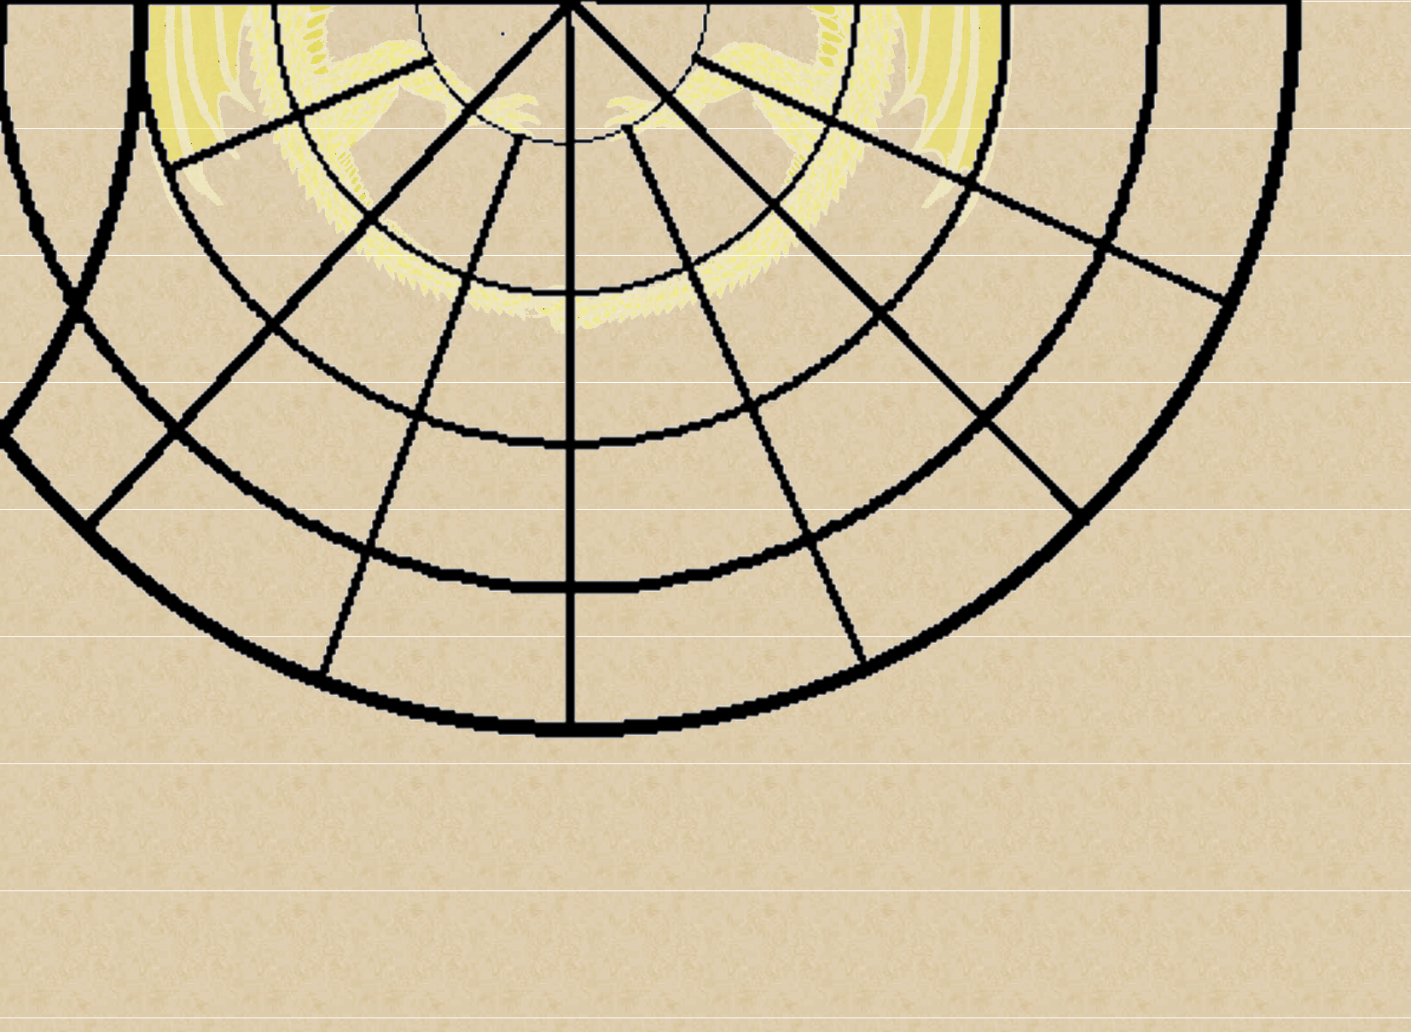

Game Pieces

Print the following two sheets on two sides of card stock and cut out for the game pieces.



Game Pieces

Print the following two sheets on two sides of card stock and cut out for the game pieces.

