BIDDING:
Player to left of dealer begins bidding. For bidding, each player bids the number of tricks they think they can win, and the suit they wish to be ‘trump’. The bidding continues clockwise around the table until all remaining players ‘Pass’ on bidding. Bidding will tell the other players what suit that player is strong in.
The bids should total the number of tricks that CAN be taken (but do not have to). Conservative bidding means you might not be ‘SET’ but also means you get less points.
Two players (27 tricks)
Three players (18 tricks)
Four players (12 tricks)
Five players (9 tricks)
Six players (9 tricks)

Possible Points:
Making Bid – 100 pts
Making a bid of MORE than half the tricks–200 pts
Making a bid of 5 tricks or more – 200 pts
Getting Set – lose 200 pts.
Getting the most tricks and making your bid – 200 pts.

PLAY:
The player to left of dealer, or most senior player, leads out whatever suit they wish. All players must follow suit. If they are out of that suit, another suit may play. Any card in the trump suit wins.
First player to 700 points wins the Game, and receives 500 pts. First player to 1000 points wins the Set and receives 500 points. First player to 2000 points wins the Match.
ENJOY!
12

The Dragon Deck
The Dragon Deck is a card deck involving nine different cards in six suits. Fifty-four cards in all.
RANKS:
The ranks in descending power are:
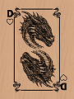  Dragon | 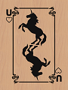  Unicorn | 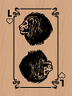  Lion
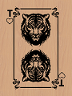  Tiger | 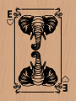  Elephant | 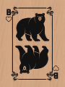  Bear
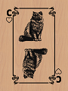  Cat | 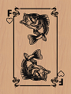  Fish | 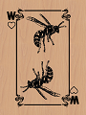  Wasp
SUITS:
The suits in descending power order are:
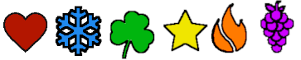
(H)eart | (I)ce | (C)lover | (S)tar | (F)ire | (G)rape
Notation in this instruction booklet will be by Rank and Suit. i.e. DH=Dragon of Hearts.
1
Dragon’s Delight
The most common of the Dragon games, this is a game that is similar to Poker but involves points. Points can be tallied for winner or loser. Sometimes points are used to pass on some menial chore from winner to loser.
There are three classes of rules. SIMPLE, STRUCTURED, and CRAZY. The rule set is declared and agreed upon before game play begins.

SIMPLE RULES:
For the youngest players, the simplest rules are used. Players ONLY PLAY FOR POINTS, one point per card dealt, discarded or LAID DOWN. Six cards are dealt, ALL in the HAND, and the UNICORN is a wild card. The UNICORN can be any other card, and any other color. The WASP is considered a CURSE card. Having one at the end of the hand disqualifies that player from that hand, so you don’t want to have one so discard it if you can. If you have one at the end of the hand, you are ‘stung’. HOWEVER, if you have 5 or more wasps (including wild cards) you have a SWARM, which outranks any other combination in the hand.
Players can discard up to 5 of their cards, and draw up to another 5, always keeping 6 cards. Each card costs a point apiece, and after TWO rounds of discard/draw, the highest hand wins all points from that round. Discarded cards are placed face UP in a discard pile. Players can ask to see what was discarded.
Combinations, in winning order:
(1)Swarm | (2) 6 of a kind | (3) 5 of a Kind | (4) 4 and 2
(5)All one Color | (6) 3 and 3 | (7) 3 and 2 | (8) 3 of a kind
(9) Two Pair | (10) One Pair | (11) High Card

2
GAME PLAY:
Cards are left in a player’s STACK in front of them, without sorting or looking at them. For each hand, all players lay THREE cards off their stack face DOWN on the table in a row. If a player does not HAVE three cards, they put down what they have. Then all players turn up the leftmost card at the same time. Highest card face-up wins the face up cards.
If highest card matches another player’s face-up card rank, the higher SUIT wins all face-up cards.
If the Highest card face-up is a DRAGON, they win ALL cards face up or down not in the STACK. If TWO OR MORE Dragons are shown face up, they are at DRAGON WAR, and those players (The ones with dragons) must turn up another card, and highest card (by RANK, not SUIT) wins. If these match (ON RANK), they continue matching. If they are out of cards in PLAY, they draw a card from their STACK, and highest RANK card wins. And that card wins ALL cards on the table not in a Stack.
If a player runs out of cards, they are OUT. Winner is the player who ends up with ALL the cards.

Dragon’s Gambit
Dragon’s Gambit is a game similar to Spades or Bridge, in that game play circles around the table, and the winner of the hand takes that ‘trick’. However, there are no partners, it is every player for themselves. With six suits and two to six players, this can be an interesting game play.
DEAL:
All cards are dealt as shown below:
# Players | #cards/player | How to Adjust Deck
2 | 27 | No Adjustment
3 | 18 | No Adjustment
4 | 12 | Remove Wasps and Fish
5 | 9 | Remove Suit of Grapes
6 | 9 | No Adjustment
11
GAME PLAY:
Player to the left of Dealer goes first, and will ask one of the other players if they have any xxxx. (Ex: Got any Bears?)
If the player asked HAS any of the card asked, they MUST hand ONE of them over. If they have NONE, they tell the active player to ‘GO FISHING’.
The player will then draw one card from the pond, and their play ends, even if they are able to ‘go out’ or ‘finish their set’ (lay down their last set of 3).
POINTS:
Players are given one point for every card in the sets they have laid down.

DRAGON WAR
Like in the game of WAR, players are dealt the entire deck, and play until one player holds all the cards. However, the rules here are slightly different. First, This game may be played by 2-6 players, and the deck is adjusted for even deal as shown under DEAL.
DEAL:
Dealer deals clockwise to all players, until all cards are dealt. As there are 54 cards in the deck, deal is as follows based on number of players:
# Players | #cards/player | How to Adjust Deck
2 | 27 | No Adjustment
3 | 18 | No Adjustment
4 | 12 | Remove Wasps and Fish
5 | 9 | Remove Suit of Grapes
6 | 9 | No Adjustment
WILD CARDS:
While there are no wild cards in this game, Dragons have a special ability as described below.

10
When two players have the same winning combination, the higher Cards win. If two All-One-Color win, the higher color wins. If both have the same color, the highest cards win. (assign values 2-9 for the Fish* to Dragon, and sum the card points.) Highest sum wins. *Remember, the Wasp will ‘sting’ you
When NONE of the players have even a pair or All-One-Color, then the highest sum of card points wins the hand. If ALL players ‘fold’ then pile continues to build through next hand. Players CANNOT fold after the third deal of a hand.
At the end of each hand, the winner of that hand receives all the points for the hand (1 point per card dealt or discarded, for any hands not ‘folded’.)
First player to reach 50 points is the winner.

Example play:
3 players are playing. They receive the following:
Player 1 - UF,BH,BF,DS,EG,CH
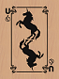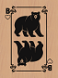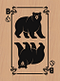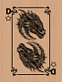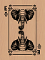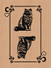
Player 2 - CG,UC,UI,DC,EF,BS
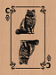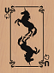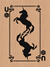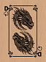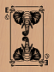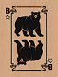
Player 3 - CI,CC,UH,FI,EI,BI
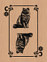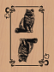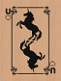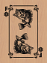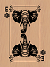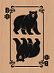
Player one can use the Unicorn (wild card) as a bear, and has Three Bears. He discards the Dragon, Elephant, and Cat.

3
Player two has Two Unicorns, which can be anything, so he pairs them with the Dragon and has Three Dragons.
He discards the other 3 cards. Player three uses the Unicorn to make Three Cats, and discards the other 3 cards.
Dealer deals each player three cards.
Player 1 - UF,BH,BF + BC,DG,EC
+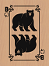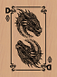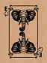
Player 2 - DC,UC,UI + US,FF,EH
+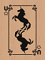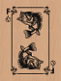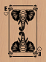
Player 3 - CI,CC,UH + EI,ES,FG
+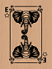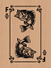
Player one has Four Bears now, and discards the other 2 cards. Player two has Four Dragons and discards the other 2 cards. Player 3 switches to the higher valued Elephants, which with the Ant makes Three Elephants and Two Cats. He discards the Fish.
Dealer deals each player their cards.
Pile is at 27 + 3+2+1 = 33 points. Player 1&2 have 91-2=89 points. Player 3 has 91-1=90.

Final status of Hand:
Player 1 - UF,BH,BF,BC + FI,LC
+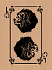
4
FOOT:
Cards on the table (foot) cannot be discarded. Players can CHOOSE which cards remain on the table on the first deal of a hand, but CANNOT exchange them for drawn cards. They must remain on the table until the end of the hand.

CRAZY RULES:
Same card game as Simple and Structured, except dealer decides in each round, before dealing, what the rules ARE. How many cards on table, how many in hand, what card(s) are cursed, what card(s) are wild. A maximum of 2 ranks can be wild or cursed. Dealer can also choose a color as cursed or wild.
Points increase per hand, up to 10 per card, and first player over 500 points is the winner.

Go Fishing
Like in the game, GO FISH, players are dealt cards, ask other players for cards, and lay down sets until they run out of cards. However, the rules here are slightly different. The dealer deals each player six cards. The goal is to lay down sets of three cards, until you have no cards in your hand. Gameplay ends on each hand after a player is out of cards in their hand, or the pond is ‘drained’ (empty).
DEAL:
Dealer deals clockwise, six cards to each player. The rest of the card deck is placed on the table and randomly spread out into a ‘pond’.
WILD CARDS:
FISH are actually WILD cards in this game, and can count for any other card.

9
However, in subsequent hands, the following happens:
HAND | # IN FOOT | # IN HAND | WILD | CURSED | PTS/  CARD
1 | 0 | 6 | U | W | 1
2 | 1 | 5 | D | F+W | 2
3 | 2 | 4 | F | C+W | 3
4 | 3 | 3 | C | B+W | 4
5 | 4 | 2 | B | E+W | 5
6 | 5 | 1 | E | T+W | 6
Highest points at end is winner. Because of how the hands fluctuate, the later hands are more subject to chance AND are higher points.
Since the later hands have 2 cursed cards, in order to prevent getting STUNG or CURSED, a player may elect NOT to discard anything, especially going into the final deal of the hand, on the chance they will receive a wasp or cursed card.
In STRUCTURED play, the player with the highest point count at the end of the hands wins.

LONG STRUCTURED:
In Long Structured, there are TWELVE hands rather than 6. Play continues with the hands 7-12 being the reverse order of above, as follows:
HAND | # IN FOOT | # IN HAND | WILD | CURSED | PTS/  CARD
7 | 4 | 2 | T | L+W | 5
8 | 3 | 3 | L | U+W | 4
9 | 2 | 4 | U | D+W | 3
10 | 1 | 5 | D | F+W | 2
11 | 0 | 6 | NONE | W | 1
12 | 0 | 6 | U+D | W | 6
8
Player 2 - DC,UC,UI,US + BG,FC
+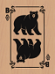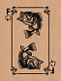
Player 3 - EI,ES,UH,CI,CC + FH
+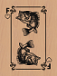
All players LAY DOWN.
The Four Dragons wins, because the Dragon is a higher Power than the Bear.
The points for the hand are a count of all cards dealt or discarded, excluding any hands that were folded. The discard pile has 9 cards from the first discard, and 5 from the second, so that’s 14 points plus the 3x6=18 cards still in hands (nobody folded). 14+18=32 points for Player 1.
Play continues until one player reaches 50 points.

Example 2:
Play CONTINUES with the 3 players. They receive the following deal for the second hand:
Player 1 - EF,FC,LG,TC,WI,UC
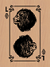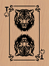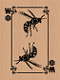
Player 2 - WF,WC,WG,DF,FG,CH
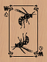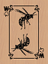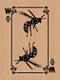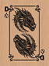

5
Player 3 - BH,BF,EH,UH,UG,LF
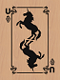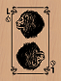
Player 1 can’t keep the wasp or he will be stung. With a wildcard (unicorn) he keeps the Unicorn and the lion, and discards the other 4. Player two wants to try for a swarm, so he discards the other 3 cards. Player 3 keeps the bears and unicorns, and discards the other 2.

Dealer deals the following:
Player 1 - LG,UC + CS,DH,DS,FS
+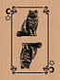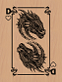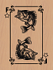
Player 2 - WF,WC,WG + UF,TG,CG
+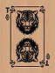
Player 3 - BH,BF,UH,UG + US,ES
+
Player 1 now has 3 Dragons, and discards the other 3. Player 2 now has 4 wasps with the unicorn as a wild card, ALMOST a swarm, and discards the other 2. Player 3 now has 5 bears with his 3 wild cards, and discards the Elephant.

6
Dealer deals a last time:
Player 1: - DH,DS,UC + WH,CF,FH
+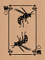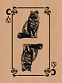
Player 2 - WF,WC,WG,UF + EF,TH
+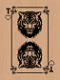
Player 3 – BH,BF,UH,UG,US + FI
+
At this point, nobody can FOLD, although players 1 and 2 would LOVE to. Both of them are STUNG. Player 2 did NOT get his swarm. So both players are out and Player 3 wins the hand with 5 bears.
The points for the hand are counted. The discard pile has 9 cards from the first discard, and 6 from the second, so that’s 15 points plus the 3x6=18 cards still in hands (nobody folded). 15+18=33 points for Player 3.

STRUCTURED RULES:
In the structured rules, all variations of the game are according to a specific structure. 6 cards are dealt each hand, and the first hand is identical to the SIMPLE rules. ALL cards in the HAND, UNICORN is the Wild Card, WASP is the CURSE card. Combinations and color/species power order are the same.

7

